Hornsea4 Project – Application No. EN010098

Objection in respect of Proposed Logistics Compound.

Lockington Parish Council have been involved in correspondence and meetings over the last two years with the Applicant ( Orsted Hornsea 4), primarily about the logistics compound which is to be constructed to supply and service the on-shore cable route/works which located on Station Road, Lockington, west of the A164 for a minimum duration of 3 years.

The Parish Council are of the view that the Logistics Compound should be located to the east of the A164 and formally object to the proposals, not having been persuaded by the case variously put forward by the Hornsea4 team as to why this is not possible. In summary, the Applicant’s case is:

- Highway analysis and advice (from ERYC) is the primary justification for locating the Logistics Compound to the west of the A164 as this enables traffic to turn left off the A164 directly on to Station Road rather than waiting for a gap in traffic to facilitate a right turn if the Compound were located to the east, with potential for queuing of HGVs on the A164 during such manoeuvre. This is all predicated on HGV traffic being controlled with arrival only from the south for the duration of the project.

- Station Road (East) is not as wide as Station Road (West) – the Traffic & Transport Environmental Statement (ES) identified Station Road to the east of the A164 as being too narrow for two vehicles to pass.

- Location of a compound east of the A164 would be contrary to the consultation feedback from landowners/tenants, namely – the land to the north of the Station Road (east of the A164) contains natural and running springs and preferably should be avoided whilst the land to the south of Station Road (east of the A164) is not preferable due to existing and future cattle farming operations.

The Parish Council’s view and counterarguments to the above can be summarised as follows:

- Station Road (west) primarily serves the village of Lockington which contains c160 houses, a School, Church and a village hall – although it is used as a through route for non-HGV’s from and to other villages/destinations. Station Road (east) primarily serves Aike which contains c30 houses. Wherever the Compound is located and whatever ‘control measures’ are in place, it will inevitably bring disruption and delays to road users from Lockington and/or Aike – accordingly, logic indicates that it should be located to the east of the A164 where the population and vehicle numbers are significantly lower as this must have less adverse impact on the local communities.

- The enforceability of the vehicle control measures is debateable and will only be applicable to HGV’s. The figures* supplied to the Parish Council by the Hornsea4 team for estimated daily average 2-way construction vehicle movements to a compound west of the A164 total 61 (30 incoming & 30 outgoing) of which 15 would be HGV’s, all travelling from the south. In short, the proposed location of the Compound and traffic safety justification is predicated on 15 HGV’s (i.e., only 7 or 8 HGV’s incoming and outgoing) per day. HGV’s exiting the Compound will still have to turn right (southwards) at the A164 junction across the traffic when a gap permits – queuing and delays on Station Road are inevitable. (* See Note below regarding the traffic figures).

Additionally, based on the figures supplied, there will be an estimated c45 daily non-HGV vehicles (presumably works vans, staff cars, catering supplies, external service vehicles, etc, etc) that will not and (arguably) cannot realistically be controlled in terms timing and/or direction of arrival/departure – adding to potential queuing and delays on Station Road (west).

The impact will be roughly the same if the Compound were located east of the A164 but the impact on the local community would be substantially different by virtue of numbers of properties & population in Lockington and Aike respectively. The location of the Compound based primarily on the low level of HGV movements is therefore disproportionate in terms of impact on the local community and traffic flows generally on the A164. Additionally, it is understood that the traffic screening exercise undertaken in conjunction with ERYC recognised the relatively low flows at the A164/Station Road junction – arguably ‘denting’ the traffic/safety rationale for locating the Compound to the west and adding to the disproportionality of its proposed location.

- If the Compound were located on the northern side of Station Road (east) in the field immediately east of the A164, the road is not narrower or too narrow for two vehicles to pass, quite the opposite -see photos below.

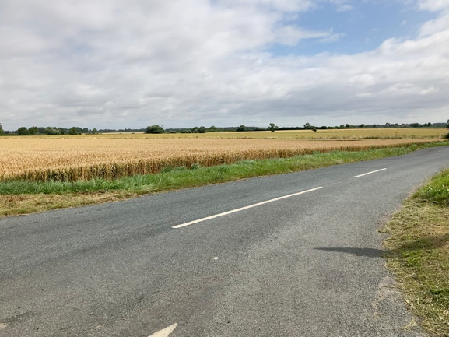
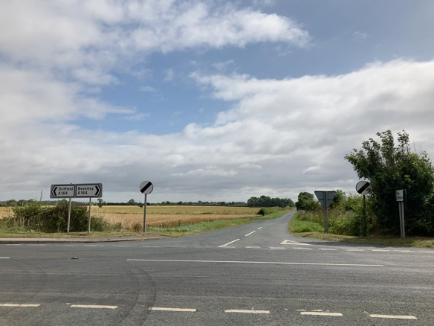

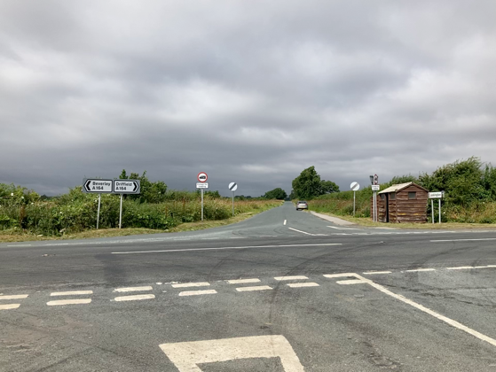
Looking East towards Aike Looking East towards Aike – the proposed alternative Compound location is on left adjacent to A164 – Station Road is wide(r) along this section.

Looking west to Lockington Village

- Following on from the above, it is questionable if a Compound immediately east of the A164 (north of Station Road) is actually affected by drainage issues. There are springs shown on the OS Map, but these are further to the east. Potential drainage arguments for not locating the Compound to the east as suggested should not be accepted unless validated.
- Additionally, Location of the Logistics Compound east of the A164 as suggested would:

- Not disrupt and give rise to safety issues for users of the public footpath from Lockington Village to the A164 which is (a) well used for users of the Beverley-Driffield bus service, and (b) just being reconstructed by ERYC.
- Not require the removal of an entire length of field hedge - environmental & biodiversity considerations.
- Be further away from the nearby Bryan Mills Cottages and Bryan Mills Farm and so mitigate potential disturbance and noise.
- Equally – if not better – serve the proposed cable route.
- Avoid the ‘real-life’ temptation for non-HGV drivers exiting the Compound (if sited to the west) to simply turn left and filter through Lockington village – thus adding to the traffic and safety concerns for Lockington residents. Hornsea4 maintain that “all construction traffic is proposed to travel to the Logistics Compound via the A164 from the south therefore avoiding traffic travelling through Lockington” BUT it is unclear what “construction traffic” means and exactly how this will be controlled in practice. Non-HGV traffic (as mentioned above) will not be limited to ‘contractor’s vehicles’ and will include inevitably include vehicles directly and indirectly associated with the project/construction works and not necessarily under Hornsea4’s control.

Summary:

The Hornse4 team are of the view that location of the Logistics Compound east of the A164 is sub-optimal and consider “that on balance, positioning the Logistics Compound to the west of the A164 would be safer and result in less delays.”

The Parish Council remain unpersuaded by their arguments and consider that the ‘balance’ is too one-sided with disproportionate weight being given to traffic considerations (particularly given the low HGV numbers involved) compared to the 3 years of disruption and delays to residents of Lockington that are inevitable with the proposed location of the Compound west of the A164. Having regard to the above, there is a case for a meaningful reassessment of the proposed location. The Applicant appears intent on locating the Compound west of the A164 but Lockington Parish Council would submit that this does not adequately respect or safeguard the interests of the local community, and an alternative option for the Logistics Compound is available that does not have the same adverse impact.
-----

(* Note: These traffic figures were supplied in writing by the Applicant in September 2020; new peak flow figures have recently been supplied following a zoom meeting in July 2021, but these are being queried as they contrast so dramatically with the previous average flow figures. No response to our queries has been received as at the date of this submission. The relevant traffic information may be in the 28 page List of Documents (possibly Volume6 -Annex7) but this does not seem to be readily or freely accessible to the Parish Council – so the latest traffic figures (and those that the ERYC have based their advice upon) remain a mystery. A supplementary sublission may be necessary by the Parish Council if and when these figures are made known).
-------------
4th December 2021
Gareth Rees
Clerk – Lockington Parish Council
lpcclerk@outlook.com
Mobile: 07768233352
Home: 01430 810141

------------

