PROPOSED “LOCKINGTON VILLAGE COMMUNITY GREEN”
The Lockington Parish Council (LPC) owns a small field along Station Road and the former Tip site at the top of Dalton Road. Neither contributes to village life or activities. Accordingly, the Parish Council has been in discussion with Dalton Estates over the past 12 months (details in the Parish Council minutes available on the LPC website) about exchanging these two land areas for a parcel of land in the centre of the village that could potentially provide some community benefit and use.
As you can imagine it has not been an easy process, but given the wish of both parties to find a satisfactory outcome, the Parish Council is now pleased to report that it is able to present a firm proposal to the village. We now wish to gauge the opinion of residents in order to make a judgement as to whether to proceed further.
The Proposal The outline terms for a potential land exchange have now been agreed (subject to contracts). The Parish Council is proposing that the paddock at the junction of Thorpe and the Beck (adjacent to Manor Farm) would transfer to the Parish Council in July 2021 when the current tenancy expires.
The land is shown on the below plan. It comprises approximately 0.6 of an acre and whilst not as large as the land area being exchanged, it does provide a readily accessible site in the centre of the village that everyone can use.
Independent Valuation Advice has confirmed that the land exchange represents a fair exchange in terms of value.

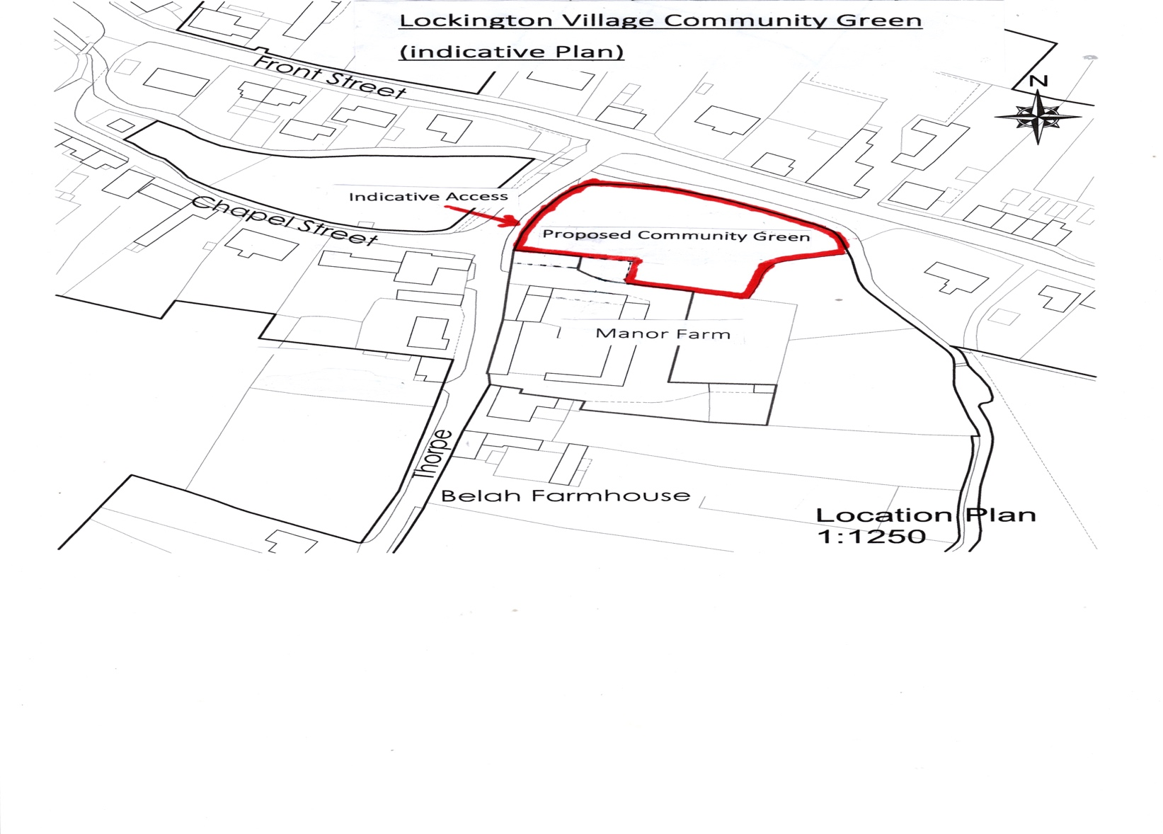
The Parish Council believes that this is a rare opportunity to significantly improve the facilities in the village,
but will only proceed if it has the support of local residents.

The Parish council sees the decision-making process as follows:
- First the proposal for the land exchange must be endorsed by residents.
- If residents support the proposal, then the next (second) stage will be decisions on the exact use of the land and facilities to be provided. For this stage, the Parish Council will invite interested residents to work on a small working group to develop an “Action Plan” which will be put forward for public comment and discussion.
- This plan will then be modified until sufficient consensus has been reached for the Parish Council to feel able to proceed. The plan must include details of the required fundraising. Any scheme must be practicable and deliverable bearing in mind that grant funding will be required for any works or equipment. Subsequent maintenance and management will also need to be considered.

Accordingly, the purpose of this Circular and the attached Questionnaire are:
- To notify residents about the proposed Land Exchange and provide an opportunity for residents to express their views.
- To invite general comments on the best use of the land which would inform the second stage of the process if the Land Exchange is successfully concluded. For example, allowing for the financial investment required, the initial thinking to date has included seating areas, tree planting and wild meadow areas, including a possible Children’s play area and/or other facilities for older children etc. However, there are no fixed ideas or plans and residents’ views are being sought (see attached Questionnaire).
- To advise that a Public Meeting will be arranged to review the questionnaire responses and discuss the proposed scheme.
- If it is felt that there is sufficient support for the Proposed Land Exchange then the Parish Council will move to form a small working group to drive this project forward and develop an Action Plan comprising a firm proposal, plans, funding and implementation.

PLEASE TAKE THE TIME TO COMPLETE THE ATTACHED QUESTIONNAIRE AND SUBMIT YOUR VIEWS.
IF YOU WOULD LIKE TO GET INVOLVED, THIS IS A GREAT OPPORTUNITY TO PROVIDE A FACILITY IN THE VILLAGE THAT WILL BE OF BENEFIT FOR ALL GENERATIONS.
YOUR HELP AND SUPPORT WOULD BE MUCH APPRECIATED.

Sorry, but there are a few caveats!
(1) The scheme will require grant funding from various sources to provide any facilities & equipment, new access, etc.
(2) Planning consent will be required
(3) Care will be needed to ensure that any use or activities do not cause a nuisance or problems to local residents, and that any required ongoing future maintenance is considered.
All these factors mean that not all suggestions for the proposed green will be achievable and may have to be phased.

Please See attached Questionnaire

PROPOSED LOCKINGTON VILLAGE COMMUNITY GREEN – QUESTIONNAIRE
- Do you endorse the Land Exchange proposed (delete as appropriate)? Yes/No

- Do you endorse the idea of a small Village Community Green on the exchanged land (delete as appropriate)? Yes/No
If you have endorsed the Land Exchange and Village Community Green Proposals:
- What would you LIKE to see provided in the proposed Village Community Green?

- What would you NOT want to see provided in the proposed Village Community Green?

- Any additional comments you or any member of your family would like to make?

- If the Land Exchange proposal is endorsed, would you be interested in getting more involved in developing the ideas for the Village Community Green and joining a small working group?

Yes/No (delete as appropriate)

- Submitting your views by September 1st:

- Please complete this questionnaire and return to Mr Gareth Rees, Clerk to Lockington Parish Council, Pasture House, 6 Front Street, Lockington, YO25 9SH OR hand it to any Parish Councillor.
- You may also scan and upload the document and send to the Parish Clerk at lpcclerk@outlook.com
- Please include your name, address and signature.
- In addition to the above, it is hoped as many residents as possible will attend the proposed Public Meeting, provisionally late September (Covid restrictions allowing).

Name (Please print) ……………………………………Signature………………………………Date……………….
Address………………………………………………………………………………………………………………………
Lastly, we will keep the Parish Council website (www.lockingtonparishcouncil.eastriding.gov.uk) updated regarding this proposal. A summary of the independent valuation advice and plans can also be seen on the website.
Additional copies of this document can be printed from our web site at www.lockingtonparishcouncil.eastriding.gov.uk.

Lockington Parish Council 30.06.2020

